Name: | Indhumathi C 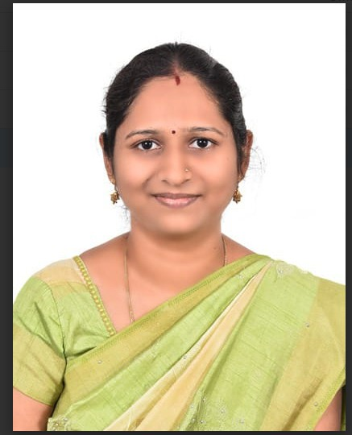
Designation: | Assistant Professor
Qualification: | B.E, M.E, (Ph. D)
Experience : (as on Dec 2026) | Industrial Experience | Teaching Experience
Experience : (as on Dec 2026) | 1 Years | 15.5 Years
Professional Body Membership | - INDIAN SOCIETY FOR TECHNICAL EDUCATION (FULL TIME)  - INTERNATIONAL ASSOCIATION OF ENGINEERS (FULL TIME)  - IEEE(TWO YEARS)

Experience:
- RMK Engineering College, Kavaraipettai as Assistant professor from August 2021 to 31.07.2024
- TJS Polytechnic College, Peruvoyal, as Senior lecturer from August 2010 to July 2021.

Publications:
- Augmented Reality based Piano Application, “Nithya A.A.;Ishwarya K.;Arunadevi R.;Benjamin A.D.;Harikesh H.;Indhumathi C”, International Conference on Computational Robotics Testing and Engineering Evaluation Iccrtee 2025, Volume , Year 2025, Pages
- Breast Cancer Severity Classification; Mesh Denoising Graph Triple Attention with Stereoscopic Scalable Quantum Convolutional Neural Networks, “Indhumathi C.;Devi S.R.;Asma M.D.;Kalpana C.;Sandhiya R.;Denis R”.2025 6th International Conference on Data Intelligence and Cognitive Informatics Icdici 2025, Volume , Year 2025, Pages 1117-1123
- Real-time Stream Processing in IoT Environments, “Rajasekar P.;Bhosale R.S.;Indhumathi C.;Sandeep K.V.;Prasanthi Kumari N.;Rajendiran M”.Proceedings of 9th International

Conference on Science Technology Engineering and Mathematics the Role of Emerging Technologies in Digital Transformation Iconstem 2024, Volume , Year 2024, Pages
- “An Investigation of Smart Detection for Small Lung Tumor with Tumor Pattern Recognition Algorithm”, International Conference on Artificial Intelligence and Knowledge Discovery in Concurrent Engineering (ICECONF), Year 2023.
- “AI-Powered Visual Aid System for the Blind”, International Conference on Research Methodologies in Knowledge Management, Artificial Intelligence and Telecommunication Engineering, Year 2023.
- “Doctor Appointment Booking System Using Content Based Filtering Recommendation”, International Journal of Mechanical Engineering, Year 2022.
- “Cryptocurrency Exchange Rate Prediction using ARIMA Model on Real Time Data”, International conference on intelligent computing and control systems, Year 2022.
- “Prominent Rule Control-based Internet of Things: Poultry Farm Management System”, 3rd International Conference on Power, Energy, Control and Transmission Systems, ICPECTS 2022 - Proceedings, Year 2022.

Patent:
- “A Federated Intelligence Platform for Real Time UPI Fraud Detection”, IP Clinic,2025.
- “An Edge Computing Apparatus for Flexible Allocating Computing Resource and MEthod Thereof”, The Patents Act , 1970, Year 2022.

Book Chapter:
“Application of Federated Learning and Gestural Technology in Healthcare” 10.4018/978-1-6684-3795-7.ch012, ISBN13: 9781668437957|ISBN10: 1668437953|ISBN13 Softcover: 9798337316864|EISBN13: 9781668437964, 2025

NPTEL Certification:

- NPTEL - Programming Domain Scholar completed.
- The Joy of Computing Using Python (Top Performing Mentor)
- The Joy of Computing Using Python (Elite)
- Design Thinking – A Primer (Mentor)
- Programming in Java (Mentor)
- Enhancing Soft skills and Personality Development (Top Performing Mentor)
- Enhancing Soft skills and Personality Development (Elite)

International Certificate:

- Oracle Certified Database SQL Expert[87%]

Achievements:

Recognized as a NPTEL DISCIPLINE STAR in Jul-Dec 2025.

Received Best Teacher award -2024 from LIONS CLUB.
- IEEE proctor Appreciation Award for the IEEEXtreme 17.0 programming competition .

