Name: | ARUNA DEVI R 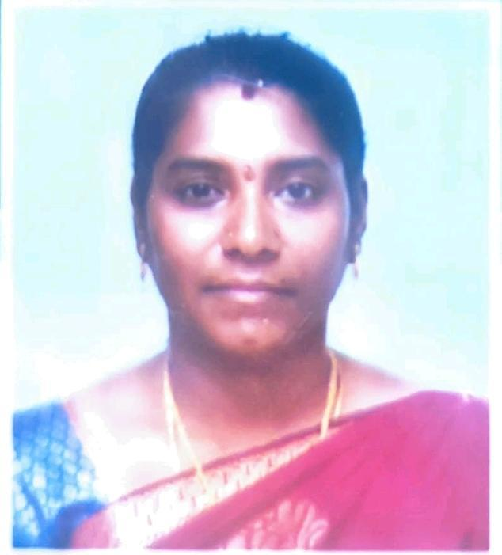
Designation: | Assistant Professor
Qualification: | B.E,M.E,(PhD)
Experience | 10 YEARS 8 MONTHS
Journal & conference Publication | 24
Area of Specialization | Networks & IOT
Patents | 4
NITTT | COMPLETED 8 MODULES
Number of NPTEL course Completed | 4
Book Published | 1
Book Chapter | 1
Professional Body Membership | - IEEE membership  - IAENG membership

EXPERIENCE SUMMARY
Over all experience of 10 Years 8 Months as teaching staff.
- Working as an Assistant Professor (CSBS) in Sri Sairam Engineering College, Tambaram (6th June 2024 to till date).
- Worked as an Assistant Professor (CSE) in Prince Shri Venkateshwara Padmavathy Engineering college, Ponmar (11th Sep 2022 to 9th May 2024).
- Worked as an Assistant Professor (CSE) in SMK Fomra Institute of Technology, Kelambakkam (19th Aug 2021 to 9th Sep 2022).
- Worked as an Assistant Professor (CSE) in PRIST UNIVERSITY, Manamai. (21st Aug 2019 to 24th April 2021).
- Worked as an Assistant Professor (CSE) in Indira Gandhi College of Engineering and Technology for Women, Chengalpattu. (1st Aug 2014 to 4th April 2019).

CONFERENCE

- Presented a paper entitled as “CAMOUFLAGING WORM PROPAGATION AND DETECTION” in the National Conference on “Adhi College of Engineering and Technology” organized by Department of Information Technology.
- Presented a paper entitled “INTERFIREWALL OPTIMIZATION ACROSS ADMINISTRATIVE DOMAINS FOR ENABLING PRIVACY PRESERVING AND SECURITY” in the International Conference on “Vels University”.
- Presented a paper entitled as "FAST CALCULATION OF HARALICK TEXTURE FEATURES TO DETECT GLAUCOMATOUS USING NEURAL NETWORK TECHNIQUES” in the International Conference on Karpagam College of Engineering.
- Presented a paper entitled “SECURING MANET FROM ATTACKS USING HYBRID CRYPTOGRAPHIC TECHNIQUES” in the International Conference on ARM College of Engineering and Technology.
- Presented a paper entitled as “INTERFIREWALL OPTIMIZATION ACROSS ADMINISTRATIVE DOMAINS FOR ENABLING PRIVACY PRESERVING AND SECURITY” in the International Conference on “S.A Engineering College”.
- Presented a paper entitled “CLASSIFICATION OF CUSTOMERS USING CHURN IN MACHINE LEARNING” in the International Conference on Research Innovation in Science, Engineering and Technology, Kings Engineering college of Technology.
- Presented a paper entitled “Heart Failure Prediction using Machine Learning Algorithm” in IEEE Mysurucon 2022-The Mysore subsection Flagship International Conference in October 2022.
- Presented a paper entitled “Decoding and Analyzing consumer Feedback for companies and Goods using Machine Learning” in the international conference on Artificial Intelligence and Smart Energy on “JCT college of Engineering and Technology” (2023).
- Presented a paper entitled as “An Advance strategy for Efficient Agricultural Production using Machine Learning” in international conference on Automation, Computing and Renewable systems (ICACRS-2023).

PUBLICATIONS
- Paper published in International Journal “Interfirewall Optimization Across Administrative Domains for Enabling Privacy Preserving and Security” – International Journal of Computer Science and Information Technology (IJCSIT), Volume 4, Issue 6, 2013, pp. 808–812.
- Paper published in International Journal “Increasing Throughput Efficiency of Ad-Hoc Cognitive Radio Networks Using Neural Network Techniques” – IOSR Journal of Engineering, Volume 8, Issue 4, November–December 2013.
- Paper published in IEEE Conference “Interfirewall Optimization Across Administrative Domains for Enabling Privacy Preserving and Security” – IEEE International Conference on Information Communication and Embedded Systems (ICICES), 2013.
- Paper published in International Journal “Data Security Using Artificial Intelligence Algorithm for Cloud Computing” – International Journal of Research in Engineering and Technology (IJRET), 2015.
- Paper published in International Journal “An Analysis on Storage and Security over Cloud Platform” – The International Journal of Analytical and Experimental Model Analysis, January 2020.
- Paper published in International Journal “Home Automation Using IoT and Android App” – The International Journal of Analytical and Experimental Model Analysis, January 2020.
- Paper published in International Journal “A Novel Method to Modelling and Detection of Camouflaging Worm” – Journal of Interdisciplinary Cycle Research, April 2020.
- Paper published in International Journal “Machine Learning Classification of Active Customers Using Churn” – International Journal of Computing Algorithm, December 2021.
- Paper published in IEEE Conference “Decoding and Analysing Consumer Feedback for Companies and Goods Using Machine Learning” – IEEE International Conference on Artificial Intelligence and Smart Energy (ICAIS), 2023.
- Paper published in IEEE Conference “An Advanced Strategy for Efficient Agricultural Production Using Machine Learning” – IEEE International Conference on Automation, Computing and Renewable Systems (ICACRS), 2023.
- Paper published in IEEE Conference “Investigating the Benefits of Text Mining for Information Analysis” – IEEE International Conference on Paradigm Shift in Information Technologies with Innovative Applications in Global Scenario (ICPSITIAGS), 2023.
- Paper published in IEEE Conference “Outcome Based Predictive Analysis of Automatic Question Paper Generation Using Hybrid MLP-CNN Approach” – IEEE International Conference on Sustainable Communication Networks and Applications (ICSCNA), 2023.
- Paper published in IEEE Conference “Unsupervised Deep Learning Approaches for Anomaly Detection in IoT Data Streams” – IEEE Fourth International Conference on Smart Electronics and Communication (ICOSEC), 2023.
- Paper published in IEEE Conference “An Investigation into Robust Video Watermarking Techniques” – IEEE International Conference on Computing Communication and Networking Technologies (ICCCNT), 2024.
- Paper published in IEEE Conference “Enhancing Image Classification with Adversarial Networks” – IEEE International Conference on Computing Communication and Networking Technologies (ICCCNT), 2024.
- Paper published in IEEE Conference “Exploring the Experimental Possibilities of AI-Based Real-Time Virtual Reality Assisted Touchless Home Appliance Control” – IEEE International Conference on Innovative Sustainable Technologies for Energy, Mechatronics and Smart Systems (ISTEMS), 2024.
- Paper published in IEEE Conference “Mobile Device Security in Wireless Networks: Challenges, Issues and Solutions” – IEEE 15th International Conference on Computing, Communication and Networking Technologies (ICCCNT), 2024.
- Paper published in IEEE Conference “An Efficient Visual Cryptography Methods for Secure Image Transmission in IoT Communication Networks: Challenges and Advancements” – IEEE International Conference on Research Methodologies in Knowledge Management, Artificial Intelligence and Telecommunication Engineering (RMKMATE), 2025.
- Paper published in IEEE Conference “Augmented Reality Based Piano Application” – IEEE International Conference on Computational Robotics, Testing and Engineering Evaluation (ICCRTEE), 2025.
- Paper published in IEEE Conference “Hybrid Random Forest-CNN Model for Epileptic Seizure Prediction: A Deep Learning Approach” – IEEE International Conference on Computational Robotics, Testing and Engineering Evaluation (ICCRTEE), 2025.
- Paper published in IEEE Conference “Innovative IoT and Machine Learning Approach for Smart Baby Monitoring” – IEEE International Conference on Computing and Communication Technologies (ICCCT), 2025.
- Paper published in IEEE Conference “IOT Based Smart Home Automation Using ESP32” – IEEE International Conference on Computing and Communication Technologies (ICCCT), 2025.
- Paper published in IEEE Conference “Plastic Remediation in Rural Water Bodies” – IEEE International Conference on Computing and Communication Technologies (ICCCT), 2025.
- Paper published in IEEE Conference “Tech for Inclusivity: A Universal Communication Device for Diverse Expression” – IEEE International Conference on Computing and Communication Technologies (ICCCT), 2025.

PATENT DETAILS

Accident Detection using Smart Rescue System, Patent No: 202341012989, Status: Published, Date: 17/03/2023.

Variational Image Based Graphical Password for Secure Authentication, Patent No: 202541015019A, Status: Published, Date: 07/03/2025.

Predictive Analytics Model for Indian Family Law Cases, Patent No: 202541015104A, Status: Published, Date: 21/03/2025.

Network Security Hub, Patent No: 455400-001, Status: Granted, Date: 15/04/2025.

CERTIFICATIONS

NPTEL Online certification on Design & Implementation of Human-Computer Interfaces[ELITE]
- NPTEL Online certification on Cloud Computing[ELITE]
- NPTEL Online certification on Computer Networks and Internet Protocol[ELITE]
- NPTEL Online certification on Introduction to Internet of Things[ELITE]
- Successfully completed all eight modules of the National Initiative for Technical
Teachers Training (NITTT).

BOOK PUBLICATIONS

- Published a book titled “Cyber Security” (ISBN-978-93-6674-393-6) under Scientific International Publishing house.

BOOK CHAPTER

- Published a Book Chapter titled “ Improve Urban Sustainability:Sophisticated Pollution Control and Environmental Monitoring in Safer Cities” under IGI Global Scientific Publishing(Indexed in Scopus).

ACHIEVEMENTS

- Received Best Teacher award -22024 from LIONS CLUB.
- IEEE proctor Appreciation Award for the IEEEXtreme 17.0 programming
competition.
- NPTEL Mentor Appreciation Award for the NPTEL online Certification Course.
- Faculty Coordinator Appreciation Award in hosting ATAL FDP on AI and Quantum Computing:Glimpsing NEar the Future in 2025.
- NPTEL Top Performing Mentor Appreciation Award for the role as Mentor for the NPTEL online Certification Course on “Cloud Computing “during Jul -Dec 2024.

